Title: Realm of Elements
Overview: "Realm of Elements" is a strategic two-player board game set in a mystical world where players take on the roles of powerful mages. Their goal is to harness the forces of nature and magic to gain control over the realm. This game combines elements of strategy, tactics, and spellcasting.
Components:
- Game Board: The game board is a square grid with 8x8 cells. Each cell represents a terrain type, such as Forest, Mountain, Lake, and Plains.
- Mages: Each player has a set of 5 mage pieces, representing Fire, Water, Earth, Air, and a Spirit Mage. These pieces are uniquely shaped.
- Guards: Each player also has a set of 5 guard pieces, which play a protective role in the game.
- Spells: A table of spells is available for players to cast during their turns. These spells are categorized into offensive, defensive, and utility spells.
Setup:
- Place the game board in the center of the table.
- Each player selects a color and places their mages and guard pieces on their side of the board as follows:
x G G G G G x x
x F W S E A x x
- Spells: Both players start with 5 spell tokens and gain 1 additional token each turn. Every 5 turns, the token gain rate increases by 1.
Gameplay: "Realm of Elements" is played in turns, with each player taking alternate turns consisting of two phases: Movement and Action.
Movement Phase: During the Movement Phase, a player can move three of their pieces (mages or guards) to an adjacent cell. Mages receive an extra tile of movement when starting on their favorable terrain.
Action Phase: During the Action Phase, the player can choose one of the following actions:
- Attack (1v1): Choose one of your pieces to attack an adjacent enemy piece. Mages can eliminate opposing mages of different elements instantly, even if protected by a guard. Mages can attack guards, but both the attacker and defender are removed from the board. Guards can also attack mages (guards can intercept, attacker won’t also die). The attacker takes the defender's place.
- Cast Spell: Spend spell tokens to cast spells, provided you have enough tokens (determined by the spell's cost). Each player can cast a maximum of two spells per turn (this limit increases every 10 turns). Spells are cast by the mage of the corresponding element within a range of 2 in each direction. The range may vary based on the terrain they occupy.
- Guard: Guards can protect adjacent mages by intercepting attacks. If an enemy piece attempts to attack a mage protected by a guard, the guard is removed from the board instead of the mage. Additionally, spells cannot be cast through a guard (the guard blocks the spell).
Special Rules:
- Terrain Effects: Terrain influences movement and spell range. Standing on favorable terrain increases movement by 1 tile and extends spell range by 1 tile, while unfavorable terrain shortens spell range by 1 tile.
- Victory Condition: The first player to eliminate their opponent's Spirit Mage wins the game.
Spell Table:
 | Fire Spells | Water Spells | Earth Spells | Air Spells | Spirit Spells
Attack:  Attack an opponents piece. | Fireball  Cost: 3  Effect: Kill the target give space Inferno effect for 1 turn. | Icy Spear  Cost: 2  Effect: Kill the target. | Rockslide  Cost: 3  Effect: Kill the target and make space unavailable for two turns.  Nat: overgr. | Gale Force  Cost: 3  Effect: Kill the target and push back surrounding pieces by one. | Soul Siphon  Cost: 3  Effect: Kill the target and take one spell token from the oponent if they have at least 1 token.
Defense:  Defend the mage in question and one adjancend guard of choice. | Blazing Barrier  Cost: 2  Effect: Immune to attacks (not spells) for one turn. | Aqua Shield  Cost: 2  Effect: Immune to spells for one turn. | Stone Wall  Cost: 2  Effect: Immune to spells for one turn. | Aerial Shield  Cost: 2  Effect: Apply spell cast on mage on attacker as well, lasts for one turn. | Ethereal Shield  Cost: 2  Effect: Immune to spells for one turn.
Utility:  Apply an effect to pieces or the board. | Inferno  Cost: 4  Effect: 3 by 1 Area in which every piece dies that passes through, can’t be cast on full squares, lasts for two turns. | Tidal Surge  Cost: 4  Effect: Push back all pieces from range plus 2 by two spaces. | Tremor  Cost: 4  Effect: 2 by 2 area make pieces skip turn. | Zephyr Step  Cost: 3  Effect: Move to an adjancent tile. | Soul Swap  Cost: 3  Effect: Switch two of your own pieces.
Path of Spells:
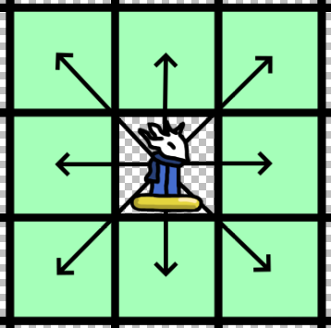
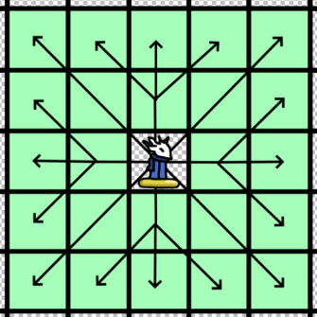
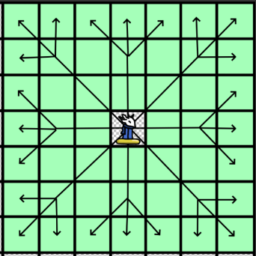

Range of 1 Range of 2 Range of 3

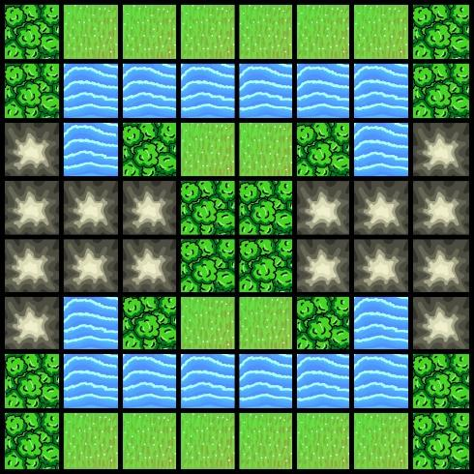
Example of a Fixed Board (Turn 90° for another one):
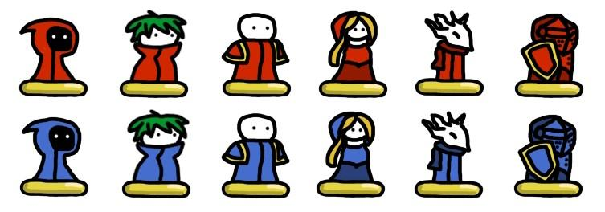
Fire Air Water Earth Spirit Guard

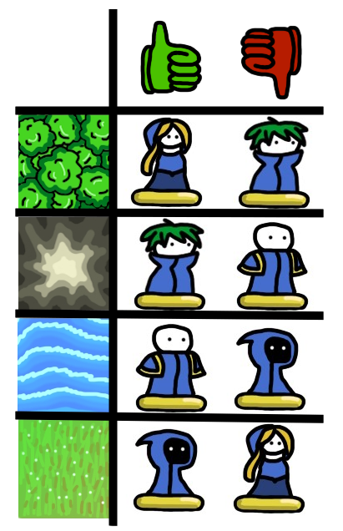
For attacking to kill directly with guards present:
